**Bridge to Cerner BTS Requirements**

**Version 1.1**

**Prepared By: Levy Lazarre and Hope Kaczmarczyk**

**Date: 1/16/2018**

Document Control 3

Resources 3

Project Distribution List 3

Document Version Control 3

1. Introduction 4

1.1 Purpose 4

1.2 Project Scope 4

1.3 Terminology Standards 4

1.3.1 Acronyms 4

1.3.2 Glossary 4

1.4 Document References 4

2. Diagram 5

3. Requirements 7

3.1 Functional Requirements 7

3.2 Messaging Protocols 9

3.2.1 Inbound to the BayCare Cloverleaf From Bridge 9

3.2.2 Outbound to Cerner 9

4. HL7 Messaging 10

4.1 Messaging Format 10

4.1.1 Segments 10

4.1*.*2 Messaging Event Types 10

4.1*.*3 Cloverleaf Configuration Files 11

4.1.4 Cloverleaf Site Location 11

4.2 Data Transformation Requirements 11

4.3 Sample Message 12

Appendix A: Risks and Concerns 12

Appendix B: Issues List 12

# **Document Control**

## Resources

|  |  |  |
| --- | --- | --- |
| **Name** | **Role** | **Email** |
| Michael J King | IS Project Manager, BayCare | Michael.King@baycare.org |
| Andrew Miller | System Engineer,  Consulting Advancement Team, Cerner | Andrew.Miller@cerner.com |
| Matthew Awosanya | Technology Consultant, Cerner | matthew.awosanya@cerner.com |
| Michael Harris | Software Engineer, Cerner | Michael.Harris@Cerner.com |
| Nicole Gitney | Director of Nursing Informatics | Nicole.Gitney@baycare.org |
| Debra Armstrong | SR Systems Analyst,  APPS - DOCUMENTATION | Debra.Armstrong@baycare.org |
| Hope Kaczmarczyk | SR Integration Analyst, BayCare EIT | Hope.Kaczmarczyk@baycare.org |
| Levy Lazarre | Integration Analyst, Baycare EIT | Levy.Lazarre@baycare.org |
| Amy S Knight | SR Systems Analyst,  APPLICATIONS ANCILLARY | Amy.Knight@baycare.org |
| Jeff Jung | BayCare Manager Laboratory IT | [Jeffrey.Jung@BayCare.org](mailto:Jeffrey.Jung@baycare.org) |
| Jane K Holz | SR Systems Analyst,  LAB COMPUTER | Jane.Holz@baycare.org |
| Danielle Sawyer | Systems Analyst,  REVENUE CYCLE APPLICATIONS | Danielle.Sawyer@baycare.org |

## Project Distribution List

## Document Version Control

|  |  |  |  |
| --- | --- | --- | --- |
| **Version** | **Date** | **Modifier** | **Description** |
| V1.0 | 01/10/2018 | Levy Lazarre | Original document |
| V1.1 | 01/16/2018 | Hope Kaczmarczyk | Added Cerner information and project diagrams |
|  |  |  |  |
|  |  |  |  |

# 1. Introduction

## 1.1 Purpose

The purpose of this document is to describe the **BTS** (Blood Transfusion Status) Interface going from Cerner Bridge Solutions to Cerner Millennium.

Bridge is a Cerner application used by nurses for the management and documentation of breast milk administration to newborns and blood transfusions to hospital patients.

## 1.2 Project Scope

The scope of this project is to automate the integration of the Cerner Bridge Solutions application with the Soarian HIS via HL7 ADT interface and the Cerner EMR via HL7 Orders and Results interfaces. The current document describes the BTS interface, from Bridge to Cerner Millennium for Blood Product Disposition.

## 1.3 Terminology Standards

### 1.3.1 Acronyms

**ADT** - Admission, Discharge, Transfer: mainly demographic and patient location data

**BTS -** Blood Product Transfusion Status/Disposition

**DTA** - Discrete Task Assay; reference data item

**HIS -** Health Information System, the source and keeper of patient demographic data

**ORU** - A HL7 Observation Result message

### 1.3.2 Glossary

**ADT Event** – Trigger event associated with a patient event: registration, admission, discharge, transfer, update…

**Alias** - An identifier used to represent an item, such as a location, order, specimen type, or result.

**Bridge** - An external Cerner Solution used by Baycare for Medical Breast Milk/Infant Feeding Management and

Transfusion Administration.

**Contributor System –** External System that sends to and/or receives data from Cerner Millennium. A “Contributor System” is built on Cerner as part of an interface or data feed.

**Contributor Source –** A source created on Cerner used to identify inbound and/or outbound aliases for data sent to and received from Foreign Systems.

**Scripting –** Custom Cerner programs written to modify, format, and filter message transactions for the interfaces. The types of scripts used by FSI are Suppression, Route, Modify Object, Modify Original, Type, and ACK.

## 1.4 Document References

1. Cerner Bridge Solutions Interface Specifications.doc

2. BM AND BMM TESTING PATIENTS.xlsx

# 2. Diagram

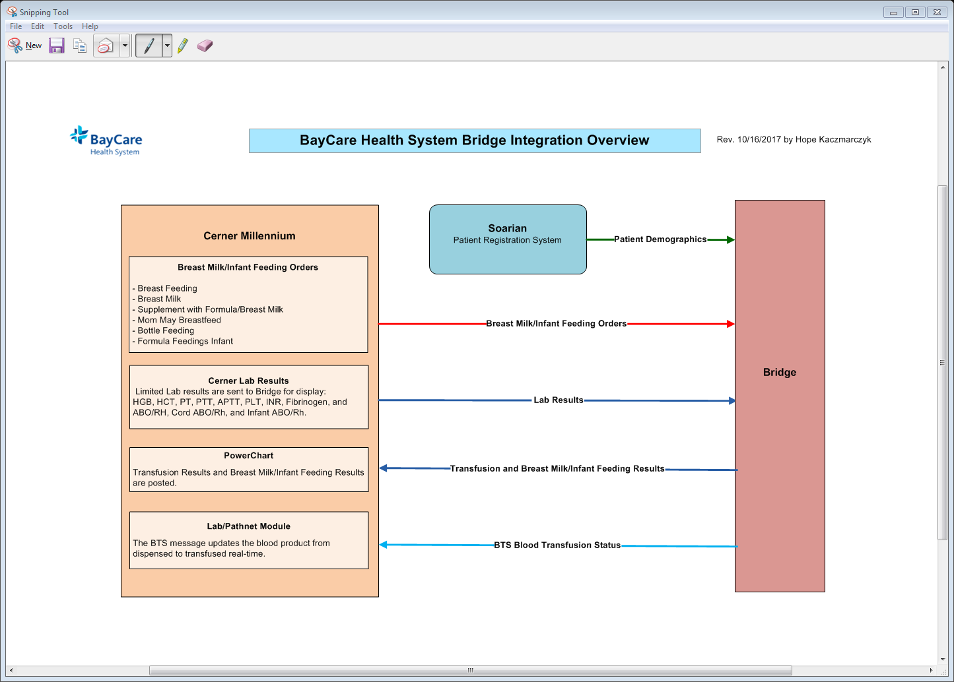

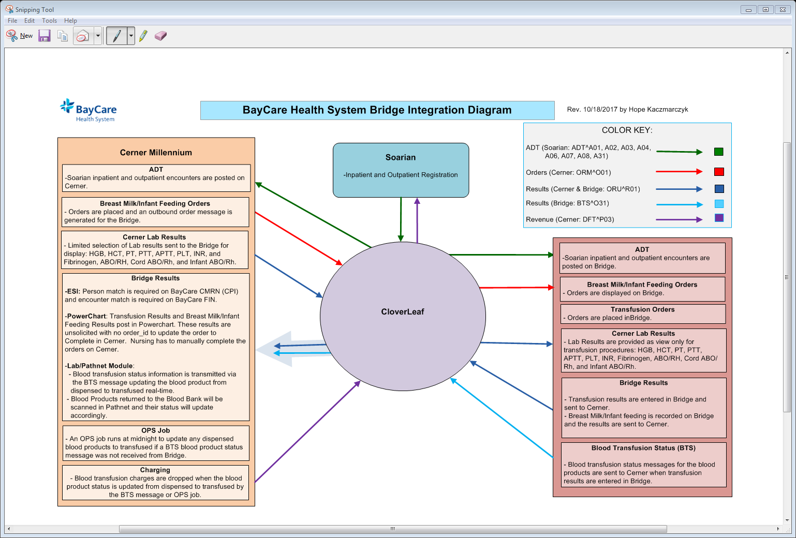

CloverLeaf Threads for Bridge Results outbound to Cerner on CloverLeaf Site: cerner_results_7_p:

# 3. Requirements

## 3.1 Functional Requirements

|  |  |  |
| --- | --- | --- |
| **Cloverleaf** |  |  |
| **Number** | **Requirement Name** | **Requirement Description** |
| FR.2018.1.0 | No result with a missing patient CPI should go to Cerner. | The CPI is used by Cerner FSI for load balancing and missing CPIs cause the Cerner interface to stall. A TCL advanced filter is used in Cloverleaf to kill any message where the CPI in PID.2 is null. |
|  |  |  |
| FR.2018.2.0 | Send the BayCare CPI in PID.2 | The BayCare CPI will be sent in PID.2, and the ID Type Code in PID.2.5 should be hardcoded to “BCCPI”. |
| FR.2018.3.0 | Send the BayCare MRN in PID.3 | The BayCare MRN will be sent in PID.3, and the ID Type Code in PID.3.5 should be hardcoded to “BCMRN”. |
| FR2018.4.0  FR2018.5.0 | Send the account number in  PID.18  Suppress the PV1 segment  In the output to Cerner | The account (FIN) number is sent in PID.18; the ID Type Code in PID.18.5 should be hardcoded to “BCFN”.  The dynamic locations sent by Bridge in PV1.3 do not exist in Cerner and would cause issues. The PV1 segment is optional in Cerner and is not necessary for the message to file properly. |

|  |  |  |
| --- | --- | --- |
| **Cerner** |  |  |
| **Number** | **Requirement Name** | **Requirement Description** |
| FR.2018.01.1  FR.2018.01.2 | New Contributor System: BRIDGE  **New Cerner Contributor Source:**  BRIDGE | The BRIDGE contributor system was created on Cerner to handle the breast milk/infant feeding orders and limited Lab results sent outbound along with the breast milk/infant feeding, transfusion, and blood product disposition results sent inbound.  BRIDGE is a bi-directional contributor system:  - Organization: BayCare Health System  - Contributor System Type: Unauth  - Contributor Source: BRIDGE  - Alt Contributor Source: Invision  - Message Format: HL7 Standard V2.x  **Special Configurations**:  - Clincal Event processing done using order catalog/DTA.  Note: This setting was required for the Blood Product Volume DTAs (aliased on code set 14003 for contributor source BRIDGE) and linked to their corresponding event codes on code set 72 for proper processing in Nursing and Lab-Pathnet Applications.  **ESI Alias Translation**:  - PID-02 External Person Id (Type: CMRN, ESI Alias Type:  BCCPI, Alias Pool: BayCare CMRN)  - PID-03 Internal Person Id (Type: MRN, ESI Alias Type:  BCMRN, Alias Pool: BayCare MRN)  - PID-18 Patient Account Number (Type: FIN NBR, ESI Alias  Type: BCFN, Alias Pool: BayCare FIN)  -ORC/OBR-03 Filler Order Id (Type: Internal Accession Number)  **ESI Ensure Parameters**:  - Person = Exist or Fail Ensure  - Encounter = Exist or Fail Ensure  - Event = Update ensure  **Person Match**:  - Alias of BayCare CMRN = Match Required  **Encounter Match**:  - Alias of BayCare FIN = Match Required  **Personnel Alias**:  - All Personnel = ORGANIZATION DOCTOR (Alias Pool: BayCare  Dr Number)  **Order Match:**  **-** Internal Accession Number = Match Required  The contributor system, Bridge, uses BayCare’s main contributor source Invision aliases for most code sets. The contributor source of BRIDGE is used for result, Blood Bank Processes, and DTA inbound aliases sent by the Bridge Solution:  - Blood Product Volume DTAs in code set 14003  - Result items (event codes) in code set 72 |
|  |  |  |
| FR.2018.01.3 | New ComServer:  ORU_TCP_BRIDGE_IN  with Type script: bridge_in_typescript  and standard_ack script | Only one interface was set up on the Cerner side for both, the breast milk-infant feeding/transfusion ORU messages and the blood product disposition BTS messages. To accommodate multiple message types on one interface, a Type script was written and attached to the new comserver, ORU_TCP_BRIDGE_IN:  bridge_in_typescript , Type script:   * Sets the message type/trigger since this interface is receiving/processing both, ORU and BTS, messages. The script sets:   oen_reply->type = concat("BTS", char(0))  oen_reply->trigger = concat("O31", char(0))  or  oen_reply->type = concat("ORU", char(0))  oen_reply->trigger = concat("R01", char(0))  standard_ack script:   * Standard script used to reply ack/nack messages back to CloverLeaf when the message is received on Cerner. |
|  |  |  |

## 3.2 Messaging Protocols

Below are listed the details for the messaging protocols that will be leveraged for this integration. Please see the reference document located on the Integration SharePoint server.

### 3.2.1 Inbound to the BayCare Cloverleaf From Bridge

* TCP MLLP Server Connection
  + HL7 2.3 BTS messages from Bridge to CloverLeaf

### 3.2.2 Outbound to Cerner

* TCP MLLP Client Connection
* HL7 2.3 BTS messages from Cloverleaf to Cerner

# 4. HL7 Messaging

## 4.1 Messaging Format

### 4.1.1 Segments

The segments utilized for this interface are:

MSH

PID

ORC

BPO

BTX

*Message Construction Notes:*

*[Square Brackets] – Optional*

*{Curly Brackets} – Repeatable*

*MSH – Message Header*

*PID – Patient ID segment*

*ORC – Common Order segment*

*BPO – Blood product order*

*BTX – Blood Product Transfusion/Disposition*

### 4.1*.*2 Messaging Event Types

Below are the messages types necessary for this integration

Supported BTS Events

|  |  |
| --- | --- |
| **Event Type** | **Description** |
| O31 | BTS message from Bridge to Cerner |

### 4.1*.*3 Cloverleaf Configuration Files

For each HL7 interface specified in Section 2 of this document, identify the Cloverleaf Configuration Files: Variants, TCL Scripts, Xlates, etc.

HL7 Variants: 2.5.1 Soarian

Xlate: bridge_cerner_bts.xlt

TCL: tpsAdvHL7Filter.tcl, tpsHL7FilterSegment.tcl

### 4.1.4 Cloverleaf Site Location

Production = cerner_results_7_p

Test = cerner_results_7

## 4.2 Data Transformation Requirements

| **Field Description** | **HL7 Field Loc.** | **Required R/O/C** | **Data Type** | **Length** | **Notes** |
| --- | --- | --- | --- | --- | --- |
| **All Segments** | **MSH, PID, PV1, OBR, OBX** | R |  |  | BULKCOPY |
| Receiving Application | MSH.5 | O |  |  | Hardcode “HNAM” |
| **Patient Identifier Segment** | **PID** | R |  |  |  |
| PID.2 (CPI) ID Type Code | PID.2.5 | R |  |  | Hardcode “BCCPI” |
| PID.3 (MRN) ID Type Code | PID.3.5 | R |  |  | Hardcode “BCMRN” |
| PID.18 (FIN) ID Type Code | PID.18.5 | R |  |  | Hardcode “BCFN” |

**Note: No data transformation done on Cerner.**

## 4.3 Sample Message

Inbound to Cloverleaf from Bridge: (Blood transfusion status)

MSH|^~\&|BRIDGE|BRIDGE|CERN|CERN|20180104140658||BTS^O31|636506716188523507|T|2.5

PID||810015876|7000016611||BMTRANSFUSIONSEVEN^TESTSEVEN||19620501000000|M||||||||||6000035751|0

ORC|SC

BPO|1

BTX|1|W036817878964|E0382^^^00||||||350||C||20180104140647|BRIDGE

Outbound from Cloverleaf to Cerner: (Blood transfusion status)

MSH|^~\&|BRIDGE|BRIDGE|HNAM|CERN|20180104140658||BTS^O31|636506716188523507|T|2.5

PID||810015876^^^^BCCPI|7000016611^^^^BCMRN||BMTRANSFUSIONSEVEN^TESTSEVEN||19620501000000|M||||||||||6000035751^^^^BCFN|0

ORC|SC

BPO|1

BTX|1|W036817878964|E0382^^^00||||||350||C||20180104140647|BRIDGE

**Go Live Date for Bridge to Cerner BTS interface: January 16, 2018**

# Appendix A: Risks and Concerns

|  |  |  |  |  |  |  |  |  |
| --- | --- | --- | --- | --- | --- | --- | --- | --- |
|  |  |  | | |  |  |  |  |
| **Number** | **Risk / Concern** | **Comment** | **Mitigation** | | |  |  |  |
| RC.2018.1.0 | No risks or concerns to report at this time. |  | |  | |  |  |  |

# Appendix B: Issues List

|  |  |  |  |  |  |  |  |  |  |  |  |  |  |  |  |
| --- | --- | --- | --- | --- | --- | --- | --- | --- | --- | --- | --- | --- | --- | --- | --- |
|  |  |  | | | | | | |  |  | |  | |  | |
| **Number** | **Issue** | **Comment** | | | | | | **Fix** | | |  | |  | |  | |
| IL.2018.1.0 | No Issues to report at this time. | |  |  |  |  |

* End of document